Call Center Simulation in NS-3 and Node.js

Advisor: Dr. Tariq Mahmood Jadoon

- Erlang C, Erlang X and Optimized Call Center Model Simulation in NS-3.26.
- Comparison of performance metrics with Real Call Center Records.
- Call Center implementation using HTTPS Server, RTCPeerConnection and Socket.io in Node.js.
Call Center Simulation in NS-3
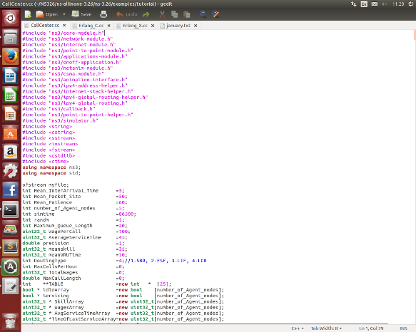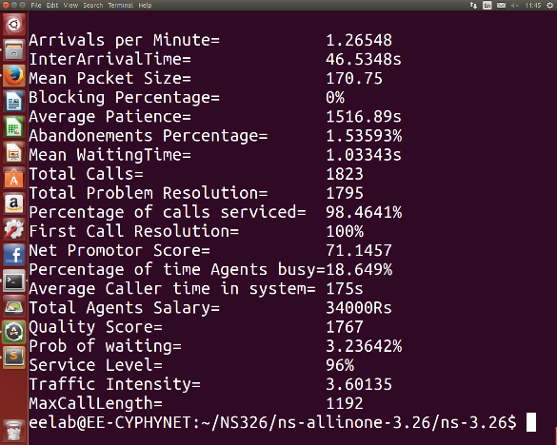
NetAnim Animation
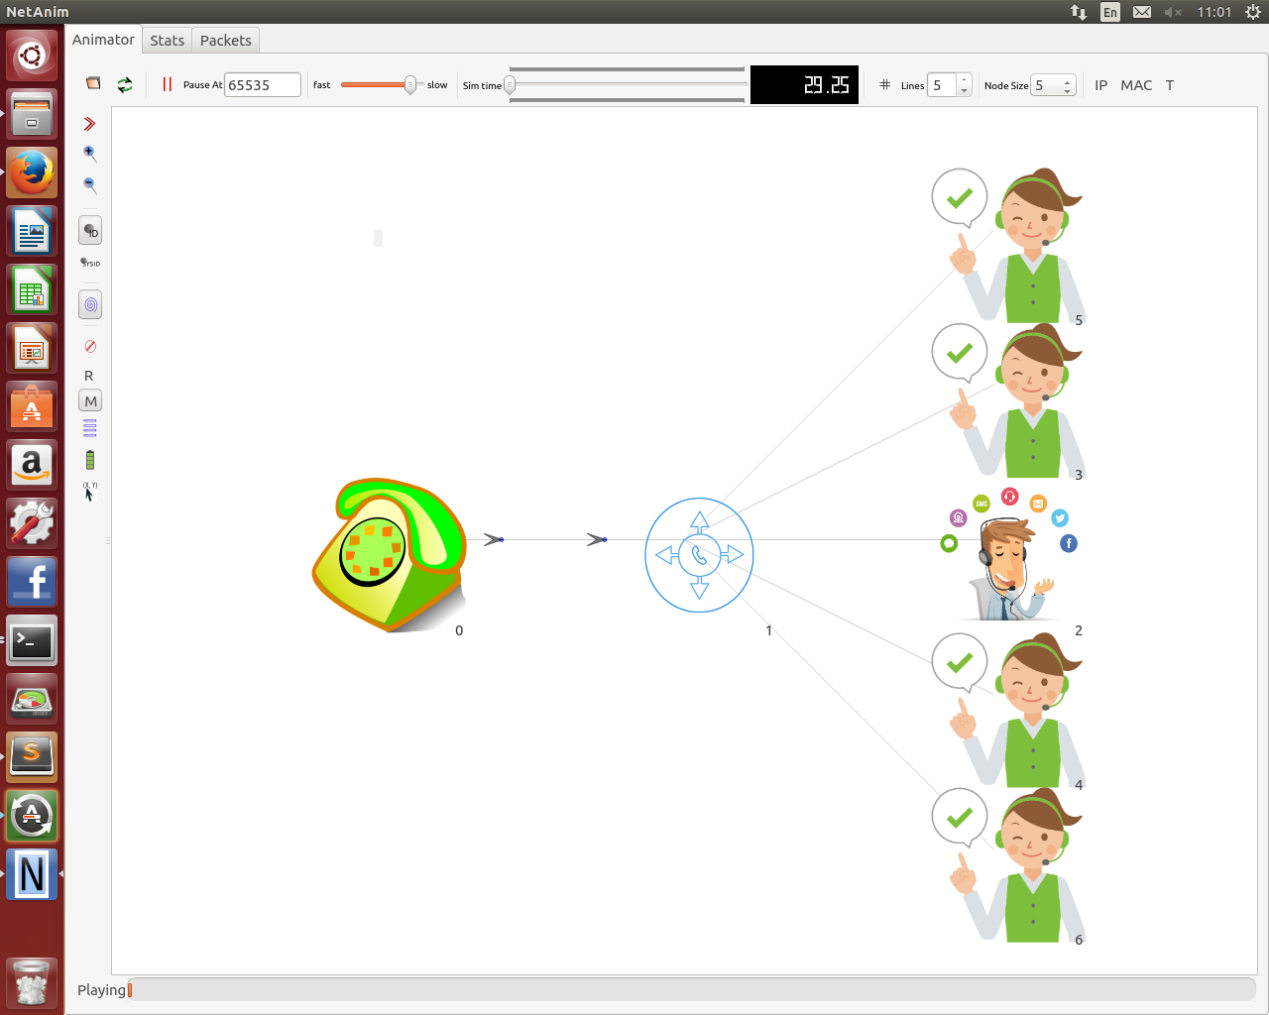
Call Center Simulation in Node.js
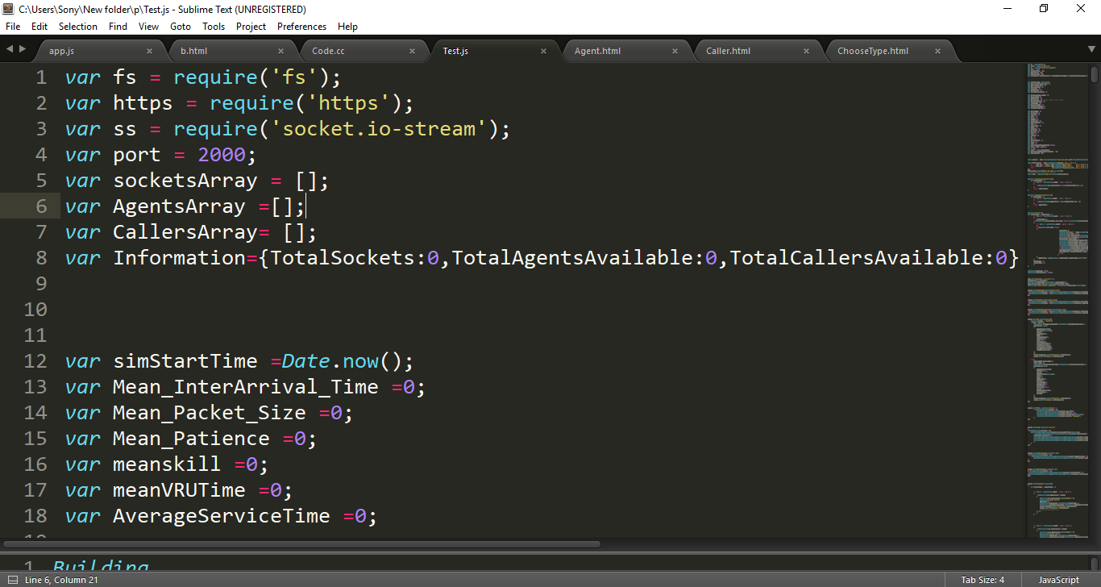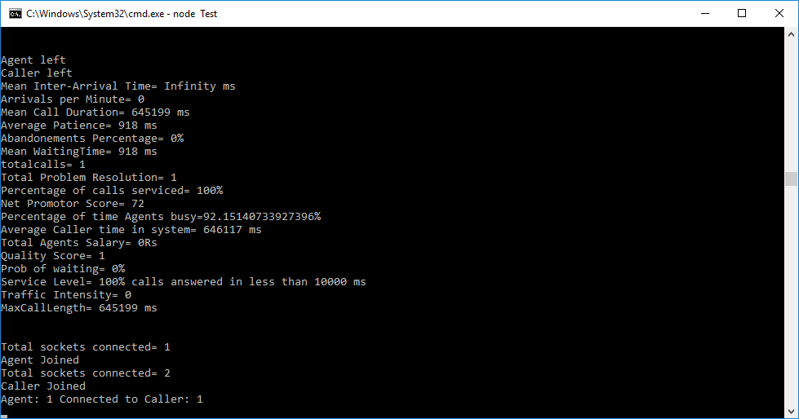
Caller and Agent Web Pages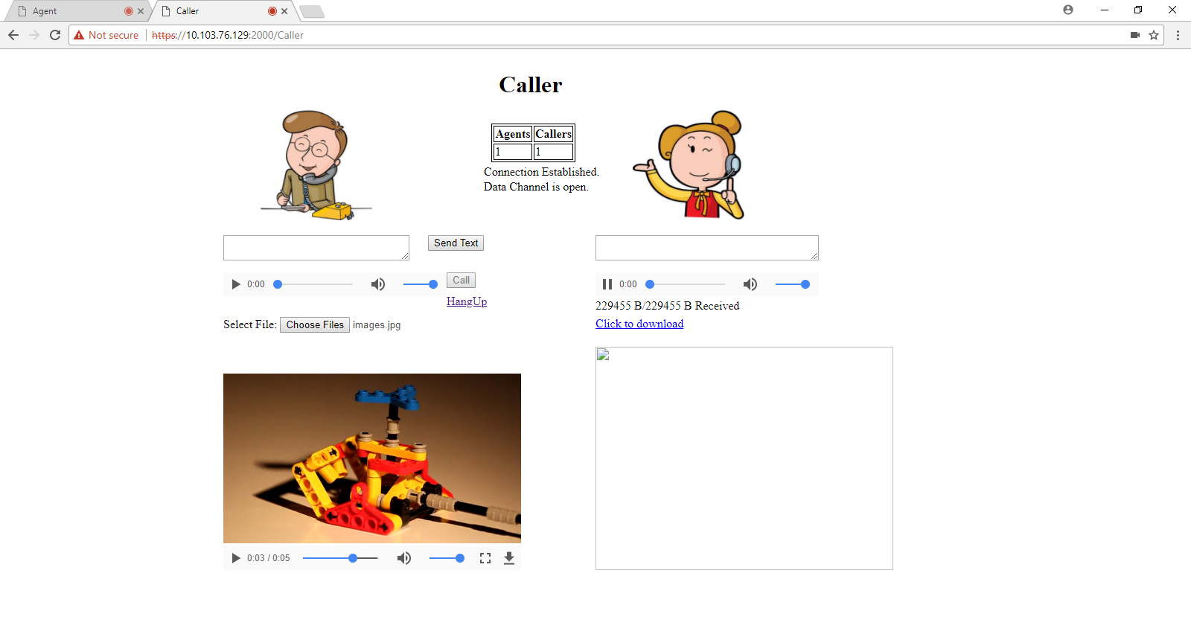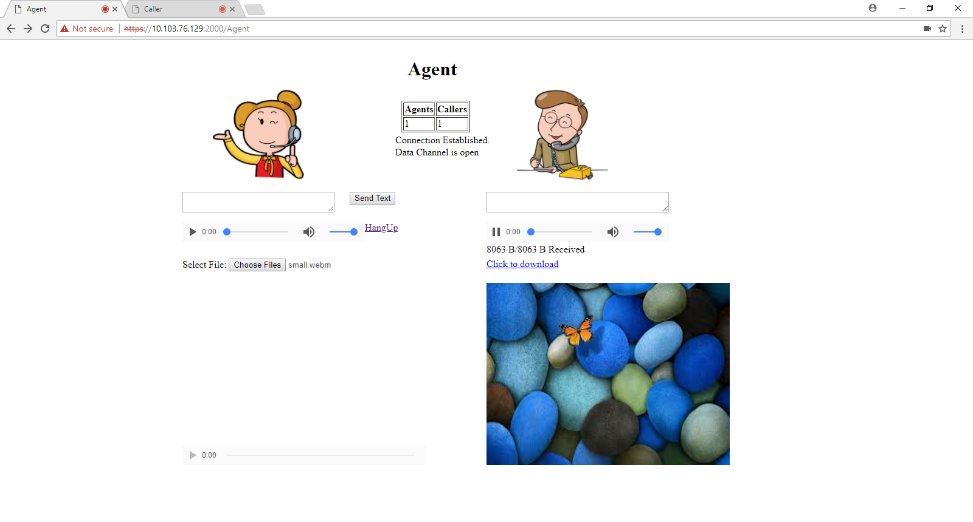
Group Members

Muhammad Shamaas Ammarah Azmat


Hira Tariq Zarmeen Khan

